**World Quant University**

**Professor: Tiberiu Stoica**

**Econometrics**

Nikolas Lippmann Pareschi - [nikolaslippmann@gmail.com](mailto:nikolaslippmann@gmail.com)

**Final Project: Forecasting Gold Price**

1. Discuss the results provided by the regression (alpha, beta, R-squared). Would you use the current model in predicting gold prices?

Code for part 1:

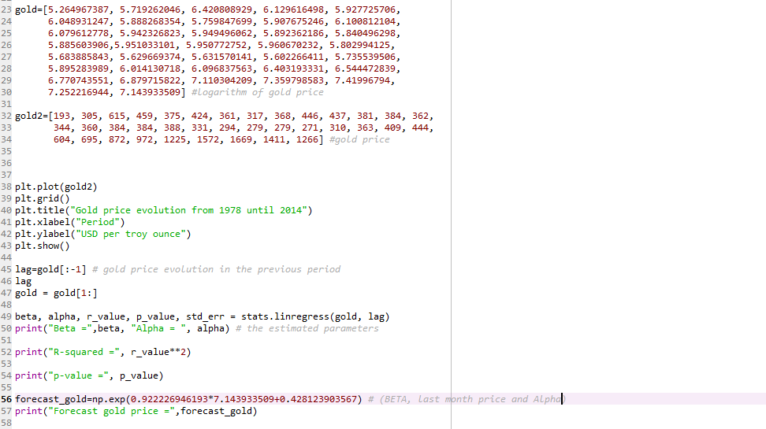

Results:

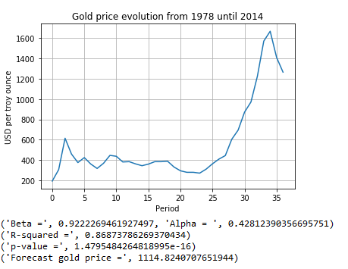

Comments: We have CTAs using successfully trend following systems for futures commodities since the 70s and the system provided is similar to them, considering that the linear regression equation predicts that the prevailing trend using lagged gold prices will remain. Also, it has an awesome p-value so I would use the system as a element of a portfolio of systems to trade gold. The R-Squared is high, not great, but our p-values are really awesome.

1. Implement an econometric model for predicting gold price evolution (use the latest available data). The econometric model can be ARMA, VAR, VEC, GARCH, Multiple Regression, Bayesian regression, Machine Learning methods or any other method that you consider suitable. Explain your model choice for this excercise. Provide the Python code and the final forecasts.

I have chosen to use a multiple linear regression considering the lagged gold prices (logs) and the value of the dollar (using the Eur/Usd logged) as a proxy. In the recent February sell off we had dollar valuing and gold losing value, together with equities. The negative correlation between dollar and gold is being stronger than the negative correlation of sell offs and gold. So maybe the dollar will add value to our prediction model. I have used the data for gold (10 years of monthly data) from index mundi and used the data from investing.com for the EUR/USD. I took both logs of gold and EUR/USD.

Code:

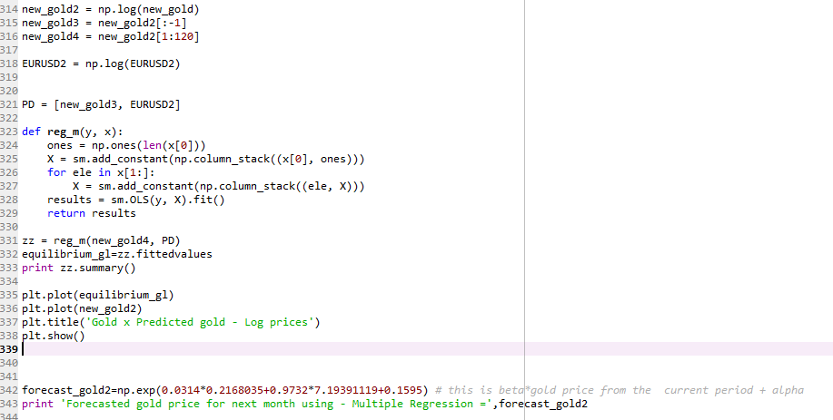

Results:

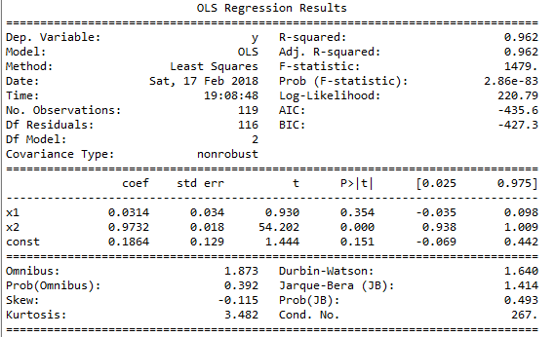

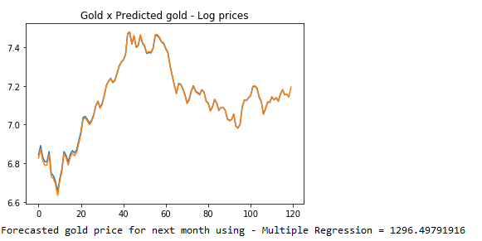

Comments: We have achieved a higher R-Squared so apparently, we are explaining more the movements of the gold prices using also the dollar. But the T-stats are not that great, for X2 (lagged log prices of gold) we had a great T-stat of 54.202. For X1 we had a low t-stat of 0.93. Maybe the super negative correlation between gold and dollar is temporary. I would trade both systems nevertheless for diversification purposes. It is possible that the second system is better if the sell off and its characteristics remain.